**INFR09051------Informatics Large Practical**

**Written Report**

**Name: Liu Rongxing**

**UUN: s1810054**

**1. Software Architecture Description**

**1.1 Sensor----------------------------------------------------------------2**

**1.2 SensorCollection-------------------------------------------------------2**

**1.3 NoFlyZone------------------------------------------------------------2**

**1.4 Sequence-------------------------------------------------------------2**

**1.5 AStarPoint------------------------------------------------------------2**

**1.6 ComparePoints--------------------------------------------------------2**

**1.7 AStarSearch-----------------------------------------------------------2**

**1.8 Generator-------------------------------------------------------------2**

**1.9 App------------------------------------------------------------------3**

**2. Class documentation**

**2.1 Sensor----------------------------------------------------------------3**

**2.2 SensorCollection-------------------------------------------------------4**

**2.3 NoFlyZone------------------------------------------------------------5**

**2.4 Sequence-------------------------------------------------------------6**

**2.5 AStarPoint------------------------------------------------------------7**

**2.6 ComparePoints--------------------------------------------------------8**

**2.7 AStarSearch-----------------------------------------------------------8**

**2.8 Generator------------------------------------------------------------10**

**2.9 App-----------------------------------------------------------------11**

**3.Drone Control Algorithm**

**3.1 Explanation-----------------------------------------------------------11**

**3.2 Graphical illustration--------------------------------------------------14**

**4. References------------------------------------------------------------15**

**1. Software Architecture Description**

My software consists of eight classes:

**① Sensor:** This class stores the information of a sensor, including its word3address, longitude-latitude coordinate, battery and reading. It has no other methods apart from simple getters and setters. I think this class is necessary because we must be able to get the accurate information about any sensors anytime.

② **SensorCollection:** This class stores the list of sensors to be visited on a given day. It is closely related to **Sensor**. It acquires data from the server and uses the data to instantiate **Sensor** one by one. **SensorCollection** will help calculate flight paths and the generate the final text file and geojson file.

③ **NoFlyZone:** This class stores the four no-fly-zones by acquiring relevant data from the server. It also has a method of checking for intrusion to the no-fly-zones given a start point and an end point. This class is necessary as it helps monitor the flight paths of the drone.

④ **Sequence:** This class finds a sequence of sensors to be visited of which the total distance travelled is minimum. It consists of two heuristics. It is necessary as it is part of the algorithms for determining the flight paths. Since I broke down the algorithms into two parts---one for deciding the sequence of sensors generally and the other for designing a specific path from one sensor to another, I used this class alone for deciding the sequence.

⑤ **AStarPoint:** Since I am using the A* search algorithm, instead of using the class **Point** in the mapbox package, I created this class to store the information of a point separately. Besides the essential values of longitude and latitude of the point, I also included other important attributes of the point such as its neighboring points and its values. All the information will be used in the A* search algorithm later.

⑥ **ComparePoints:** This class implements the comparator and compares the two **AStarPoint** by comparing their **f** value. As I am using a PriorityQueue in the A* search algorithm, this implementation will help constructing the PriorityQueue.

⑦ **AStarSearch:** This class is used for finding a specific path from one location to another using the A* search algorithm, which is the core of the entire software.

⑧ **Generator:** This class gathers the results obtained from other classes together, synthesize them for the final generation of both the text and the geojson files. For example, it firstly finds the list of sensors to be visited, then find the sequence of visiting the sensors and creates a path for each pair of adjacent sensors. Finally, it outputs the list of points travelled in the entire journey, the direction turned at each move and the nearest sensor (could be null) after each move.

**⑨ App:** This class is for the final execution of the software. It extends the class **Generator**, which means it inherits all the data in **Generator**. It will then use all these data to generate the text file and geojson file as required.

**2. Class documentation**

All global variables are in blue. All parameters are in orange.

**2.1 Sensor**

**⑴ Inheritance or Interface: None**

**⑵ Variables:**

|  |  |  |  |
| --- | --- | --- | --- |
| **Name** | **Visibility** | **Type** | **Description** |
| word3address | private | String | This is the What3Words address of the sensor. |
| reading | private | double | This is the reading of the sensor. |
| location | private | Point | This is the location of the sensor in terms of its longitude and latitude. |

**⑶ Constructor:**

|  |
| --- |
| **public Sensor (String** address**, double** reading**, Point** location**)** |
| **Description:**  Set the value of word3address, reading and location accordingly |
| **Parameters:**  address: What3Words address of the sensor  reading: reading of the sensor  location: coordinate location of the sensor |

**⑷ Methods:**

|  |
| --- |
| **public Point getLocation ()** |
| **Description:**  Get the coordinate location of the sensor |
| **Returns:** location |

|  |
| --- |
| **public double getReading ()** |
| **Description:**  Get the reading of the sensor |
| **Returns:** reading |

|  |
| --- |
| **Public String getAddress ()** |
| **Description:**  Get the What3Words address of the sensor |
| **Returns:** word3address |

**2.2 SensorCollection**

**⑴ Inheritance or Interface: None**

**⑵ Variables:**

|  |  |  |  |
| --- | --- | --- | --- |
| **Name** | **Visibility** | **Type** | **Description** |
| sensors | private | List<Sensor> | Sensors to be visited on a given date |
| **client** | private | HttpClient | Used to send [requests](https://docs.oracle.com/en/java/javase/11/docs/api/java.net.http/java/net/http/HttpRequest.html) and retrieve their [responses](https://docs.oracle.com/en/java/javase/11/docs/api/java.net.http/java/net/http/HttpResponse.html) |

**⑶ Constructor:**

|  |
| --- |
| **public SensorCollection (int** port**, int** yy**, int** mm**, int** dd**)** |
| **Description:**  Connect to the server and navigate to the maps json file with the given date. Then navigate to the detailed json file with the corresponding What3Words address for each sensor to get the coordinate location of the sensor. Store all the necessary information for each sensor and put all the sensors to the list. If the battery is below 10%, the reading should not be taken, so just record as -1. |
| **Parameters:**  port: port to be connected to on the server  yy: given year mm: given month dd: given day |
| **Throws:**  IOException, InterruptedException |

**⑷ Methods:**

|  |
| --- |
| **public JsonElement getJson (String** path**)** |
| **Description:**  Acquiring the data on the website specified by path by sending http requests. |
| **Parameters:**  path: The address of the website. |
| **Throws:**  IOException, InterruptedException |

|  |
| --- |
| **Public List<Sensor> getSensors ()** |
| **Description:**  Get the list of sensors to be visited on a given date |
| **Returns:** sensors |

**2.3 NoFlyZone**

**⑴ Inheritance or Interface: None**

**⑵ Variables:**

|  |  |  |  |
| --- | --- | --- | --- |
| **Name** | **Visibility** | **Type** | **Description** |
| zones | private | List<Polygon> | Polygons of the four no-fly-zones |
| **client** | private | HttpClient | Used to send [requests](https://docs.oracle.com/en/java/javase/11/docs/api/java.net.http/java/net/http/HttpRequest.html) and retrieve their [responses](https://docs.oracle.com/en/java/javase/11/docs/api/java.net.http/java/net/http/HttpResponse.html) |

**⑶ Constructor:**

|  |
| --- |
| **public NoFlyZone (int** port**)** |
| **Description:**  Connect to the server and obtain the no-fly-zones json file. Get the four polygons and put them to a list. |
| **Parameters:**  port: Port to be connected to. |
| **Throws:**  IOException, InterruptedException |

**⑷ Methods:**

|  |
| --- |
| **public boolean checkIntersect (Point** start**, Point** end**, Point** p1**, Point** p2**)** |
| **Description:**  Check whether the line segment joining start and end intersects with the line segment joining p1 and p2 |
| **Parameters:**  start: coordinate of one end of the first line segment  end: coordinate of the other end of the first line segment  p1: coordinate of one end of the second line segment  p2: coordinate of the other end of the second line segment |
| **Returns:**  true if two line segments do not intersect, false otherwise |

|  |
| --- |
| **public boolean checkNoFlyZone (AStarPoint** starta**, AStarPoint** enda**)** |
| **Description:**  Apply **checkIntersect** for the line segment joining starta and enda against all sides of all four polygons |
| **Parameters:**  starta: coordinate of one end of the first line segment  enda: coordinate of the other end of the first line segment |
| **Returns:**  true if the line segment does not intersect with any side of the four polygons, false otherwise |

|  |
| --- |
| **public List<Polygon> getZones ()** |
| **Description:**  Get the list of four no-fly-zone polygons |
| **Returns:** zones |

**2.4 Sequence**

**⑴ Inheritance or Interface: None**

**⑵ Variables:**

|  |  |  |  |
| --- | --- | --- | --- |
| **Name** | **Visibility** | **Type** | **Description** |
| coordinates | private | List<Point> | Coordinates of sensors |
| n | private | int | Number of sensors |
| distance | private | double[][] | Distance between sensors |
| perm | private | int[] | Optimal permutation of sensors |

**⑶ Constructor:**

|  |
| --- |
| **public Sequence (List<Point>** points**)** |
| **Description:**  **Load** points and calculate the optimal permutation of points |
| **Parameters:**  points: coordinates of sensors |

**⑷ Methods:**

|  |
| --- |
| **public void setDistance ()** |
| **Description:**  Calculate the distance between each pair of points in coordinates, and store the distance between in distance[i][j] |

|  |
| --- |
| **public int mod (int** i**, int** mod**)** |
| **Description:**  Prevent occurrence of negative number by converting it to its modulo. |
| **Parameters:**  i: the number we are converting mod: the modulus we are taking |
| **Returns:**  the modulus of i under mod. If i is negative, keep adding mod until it becomes positive. |

|  |
| --- |
| **public boolean trySwap (int** i**)** |
| **Description:**  Try to swap the sequence of the point and the point in the permutation. |
| **Parameters:**  i: index of the point to be swapped |
| **Returns:**  true if the swap gives a shorter total distance and apply the swap, false otherwise |

|  |
| --- |
| **public void reverse (int** start**, int** end**)** |
| **Description:**  Reverse the order of elements from start to end in current permutation |
| **Parameters:**  start: the start position of the part of the permutation to be reversed  end: the last position of the part of the permutation to be reversed |

|  |
| --- |
| **public boolean tryReverse (int** start**, int** end**)** |
| **Description:**  Try to reverse the order of elements from start to end |
| **Parameters:**  start: the start position. end: the last position |
| **Returns:**  true if the reversal gives a shorter total distance and apply the reversal, false otherwise |

|  |
| --- |
| **public void SwapHeuristic ()** |
| **Description:**  Apply **trySwap** repeatedly, if we find a shorter path while going through a loop, we will start a new loop until no shorter path is found |

|  |
| --- |
| **public void ReverseHeuristic ()** |
| **Description:**  Apply **tryReverse** repeatedly, if we find a shorter path while going through a loop, we will start a new loop until no shorter path is found |

|  |
| --- |
| **public int[] getPerm ()** |
| **Description:**  Get the optimal permutation of sensors to be visited |
| **Returns:** perm |

**2.5 AStarPoint**

**⑴ Inheritance or Interface: None**

**⑵ Variables:**

|  |  |  |  |
| --- | --- | --- | --- |
| **Name** | **Visibility** | **Type** | **Description** |
| theta | private | double | Base angle drone turns in |
| longitude | private | double | Longitude of the point |
| latitude | private | double | Latitude of the point |
| f | private | double | f value of the point |
| g | private | double | g value of the point |
| previous | private | double | Preceding point to form the shortest path |

**⑶ Constructor:**

|  |
| --- |
| **public AStarPoint (double** lng**, double** lat**)** |
| **Description:** Set the longitude and latitude of the point |
| **Parameters:** lng:longitude of the point, lat: latitude of the point |

**⑷ Methods:**

|  |
| --- |
| **public List<AStarPoint> getNeighbors ()** |
| **Description:** Create a list of the 36 neighbors of the point |
| **Returns:** alist of neighbors |

**2.6 ComparePoints**

**⑴ Inheritance or Interface:**

This class implements the interface Comparator<AStarPoint>.

**⑵ Variables: None**

**⑶ Constructor: None**

**⑷ Methods:**

|  |
| --- |
| **public int compare (AStarPoint** a**, AStarPoint** b**)** |
| **Description:** Order AStarPoint by comparing their values, which will be used in PriorityQueue. |
| **Parameters:** a: first AStarPoint to be compared b: second AStarPoint to be compared |
| **Returns:** -1 if values of a is smaller than values of b, 0 if equal, 1 otherwise |

**2.7 AStarSearch**

**⑴ Inheritance or Interface: None**

**⑵ Variables:**

|  |  |  |  |
| --- | --- | --- | --- |
| **Name** | **Visibility** | **Type** | **Description** |
| noflyzones | private | NoFlyZone | Used for checking no-fly-zones when finding the path |
| cutoff | private | int | Quota of the PriorityQueue |

**⑶ Constructor:**

|  |
| --- |
| **public AStarSearch (int** port**)** |
| **Description:** Set up the no-fly zones |
| **Parameters:**  port: port to be connected to |
| **Throws:**  IOException, InterruptedException |

**⑷ Methods:**

|  |
| --- |
| **public double euclidDistance (AStarPoint** p1**, AStarPoint** p2**)** |
| **Description:** Find the Euclidean distance between two points |
| **Parameters:**  p1: the first AStarPoint p2: the second AStarPoint |
| **Returns:** the Euclidean distance between p1 and p2 |

|  |
| --- |
| **public boolean inRange (AStarPoint** p**, AStarPoint** goal**)** |
| **Description:** Check whether the point is within 0.0002 degree of the goal |
| **Parameters:**  p: the current point we are at goal: our target position |
| **Returns:** true ifp is within 0.0002 degree of goal, false otherwise |

|  |
| --- |
| **public List<Point> findPath (AStarPoint** start**, AStarPoint** end**)** |
| **Description:** Find a path from start to end using A* search algorithm |
| **Parameters:**  start: starting position end: target position |
| **Returns:**  a list of points to be passed by fromstart to end |

|  |
| --- |
| **public List<Point> constructPath (AStarPoint** p**)** |
| **Description:** Find the path all the way till point p |
| **Parameters:**  p: the last point in the path |
| **Returns:** a list of points as a path from some starting point to p |

**2.8 Generator**

**⑴ Inheritance or Interface: None**

**⑵ Variables:**

|  |  |  |  |
| --- | --- | --- | --- |
| **Name** | **Visibility** | **Type** | **Description** |
| flightpaths | protected | List<Point> | List of points that the drone passes for the entire journey |
| directions | protected | List<Integer> | Angle the drone flies in each time |
| sensorspath | protected | List<Sensor> | Sensor visited in the order determined by "perm" |
| total_sensorspath | protected | List<Sensor> | Nearest sensor after each move |
| n | protected | int | Number of sensors |

**⑶ Constructor:**

|  |
| --- |
| **public Generator (int** port**, int** yy**, int** mm**, int** dd**, Point** start**)** |
| **Description:** Acquire information of the sensors on the server. Apply the two heuristics to get the optimal permutation of sensors. Find the nearest sensor to start with. Apply A* search algorithm to find the entire path. Find the directions turned in each move. |
| **Parameters:**  port: port to be connected to  yy: given year mm: given month dd: given day  start: starting position of the drone |
| **Throws:**  IOException, InterruptedException |

**⑷ Methods:**

|  |
| --- |
| **public double euclidDistance (AStarPoint** p1**, AStarPoint** p2**)** |
| **Description:** Find the Euclidean distance between two points |
| **Parameters:**  p1: the first AStarPoint p2: the second AStarPoint |
| **Returns:** the Euclidean distance between p1 and p2 |

|  |
| --- |
| **public void generatePaths (int** port**, Point** start**)** |
| **Description:** Compute flightpaths where the drone passes through sensors one by one and returns to its starting position. Compute total_sensorspath at the same time |
| **Parameters:**  port: port to be connected to start: starting position of the drone |
| **Throws:**  IOException, InterruptedException |

|  |
| --- |
| **public void setDirections (List<Point>** path**)** |
| **Description:** Calculate the angle the drone flies in. Add the angles to directions |
| **Parameters:**  path: list of points as the drone’s path (flightpaths) |

**2.9 App**

**⑴ Inheritance or Interface:**

This class is a subclass of the parent class **Generator**

**⑵ Variables:**

Same as **Generator**

**⑶ Constructor:**

Same as **Generator**

**⑷ Methods:**

|  |
| --- |
| **public String getColor (double** n**)** |
| **Description:** Get the color corresponding to the reading,expressed as a rgb-string |
| **Parameters:**  n: reading taken by the drone |
| **Returns:**  the corresponding rgb-string of the reading |

|  |
| --- |
| **public String getSymbol (double** n**)** |
| **Description:** Get the marker-symbol corresponding to the reading |
| **Parameters:**  n: the reading taken by the drone |
| **Returns:**  the corresponding marker-symbol of the reading |

|  |
| --- |
| **public void generateText (int** yy**, int** mm**, int** dd**)** |
| **Description:** Generate the required text file on the given date |
| **Parameters:** yy: given year mm: given month dd: given day |

|  |
| --- |
| **public void generateJson (int** yy**, int** mm**, int** dd**)** |
| **Description:** Generate the required geojson file on the given date |
| **Parameters:** yy: given year mm: given month dd: given day |

**3.Drone Control Algorithm**

**3.1 Explanation**

Instead of trying to find the optimal path directly, which would be extremely complicated, I broke down the algorithms into two parts---one for deciding the sequence of sensors generally and the other for designing a specific path from one sensor to another.

The first part looks like a **Travelling Salesman Problem**. There are mainly two ways of solving this problem. The first way is the greedy approach, which is to choose the nearest sensor each time, travel to that sensor and repeat the process. This method is easier to understand and execute but its result might not be ideal. Hence, I used another method which is the combination of a few heuristics that usually gives a shorter path than greedy approach. (**Reference ①**)

In the first of these heuristics (called the “Swap Heuristic”), we explore the effect of repeatedly swapping the order in which a pair of adjacent cities are visited, as long as this swap improves (reduces) the cost of the overall tour. As a result, we would reach a **local minimum**--this does not imply that we will have a global **optimum**

Let denote all the vertices (with each vertex representing a sensor) and let denote the permutation of the vertices, with .

We first set the permutation as the default permutation with simply . Then for each value of , we would try to swap the order of and check whether the total distance travelled becomes smaller. If the value is smaller we would swap ,otherwise we keep the original ordering and move on. **Notice that we are not doing this for only one loop.** Whenever there is an update of the ordering while going through a loop, we would start a new loop after that until we can see no improvement from these swaps.

The TwoOpt Heuristic is another heuristic which repeatedly makes “local adjustments” until there is no improvement from doing these. In this case the alterations are more significant than the swaps - this method repeatedly nominates a contiguous sequence of cities on the current tour, and proposes that these be visited in the reverse order, if that would reduce the overall cost of the tour. For each pair of value , we would consider the effect of reversing the segment from (in other words, to change . If this reversal will make the total distance travelled (strictly) shorter, we would commit to it, otherwise we move on. **Again, we are not doing this for only one loop of .** Whenever there is a reversal committed while going through a loop, we would start a new loop until we can see no further improvement.

In conclusion, we start with a default permutation of vertices (sensors), apply Swap Heuristic followed by TwoOpt Heuristic to the permutation and we would get a sequence of sensors to be travelled.

Now that we have our sequence, we need to travel from one sensor to another. Usually we could just travel in the straight line, which is the fastest way. However, in the context there are some no-fly zones that our drone is not supposed to cross.

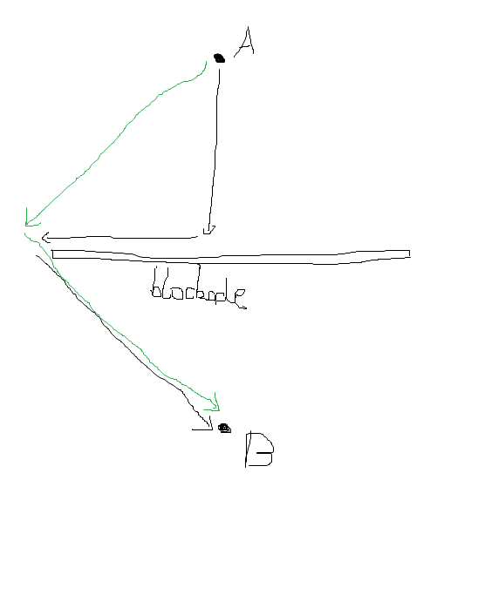

As can be seen from the figure above, suppose we are going to travel from A to B. Normally we would start travelling in the direction towards B which is shown by the black arrows and we would succeed if there is no blockade between A and B. However, when we realize that there is actually a blockade, we would have to take a detour and the total distance travelled will definitely be longer than the green ones which is determined in advance.

Hence, I decided to use the A* search algorithm. (**Reference ②**) The main idea of using A* search algorithm is that of all the points we can travel to each time, we find a point with lowest . Here is the cost of travelling from the starting point to and is the estimated cost of travelling from to the goal. In this context, I used the Euclidean Distance as the metric to determine . We repeat the process until reaching the end.

We firstly create a list which stores the potential points as our candidate. Then we find the point **(**call it **current)** with the smallest We can use a **PriorityQueue** to store those candidate points because we just need to call the method **poll()** to get that specific point, which is very efficient. After having found **current**, we would check through each point (call it **neighbor**) of its neighbors with the condition that the drone does not intrude any no-fly-zones when flying from **current** to **neighbor**. We set of **neighbor** as ; then calculate of **neighbor**; set **current** as the point immediately preceding the neighbor on the cheapest path from the start; and add **neighbor** into the candidate list. The process is repeated until we have reached the target point or there is no more pointin the list to be evaluated. Sometimes during the computation, we might happen to have too many points in the **PriorityQueue,** which slows down the computation drastically. To prevent this, we could set a quota for the **PriorityQueue.** If the size of the **PriorityQueue** exceeds the quota, we will take the point with lowest as our new starting point, record the path from the starting point to that point, start a new loop and finally concatenate the paths we obtained along the way together.

When we reach the target point, we keep acquiring its preceding points and in the end we will have a list of points, which is exactly the path we are looking for.

The drone is designed to fly a fixed amount of distance 0.0003 degree each time, so it is extremely difficult to make it fly to the exact point. Instead, since the drone can take reading as long as it is within 0.0002 degree from the sensor, we would consider a point reaching the goal when it is within 0.0002 degree from the goal. This would be applied when travelling from one sensor to another as well as returning to the starting point.

**3.2 Graphical Illustration**

This figure below shows the flight paths and markers on 2020-01-01. As can be seen from the figure, the path is very efficient as there is hardly any “back and forth” path. The drone also does not intrude any no-fly zones (sometimes it flies along the edge, but never enters).

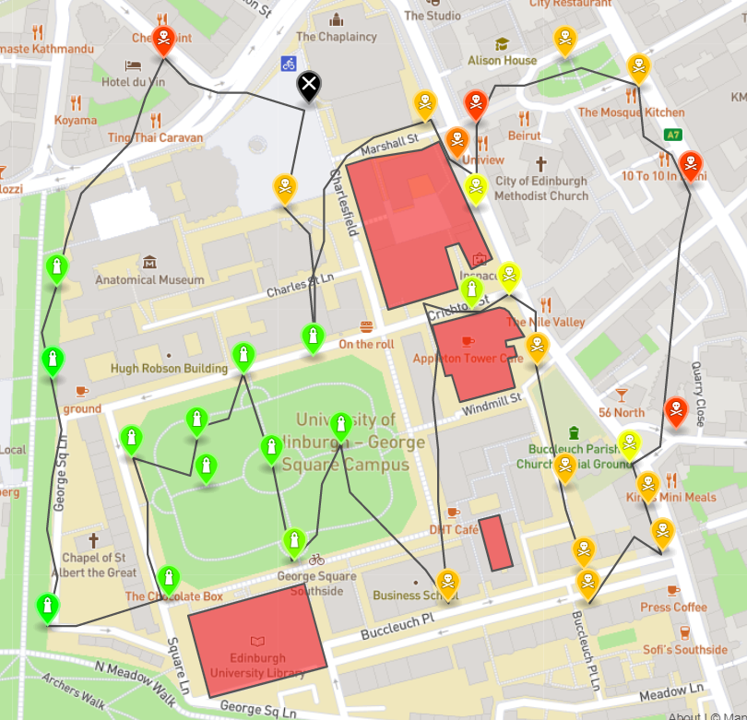

This figure below shows the flight paths and markers on 2020-02-02. As can be seen from the figure, the path takes advantage of the fact that the drone can take reading anywhere within 0.0002 degree around the sensor. Hence, it seems that the drone is never close to the sensor “laws.merit.bleak”, but it came within 0.0002 degree around the sensor.

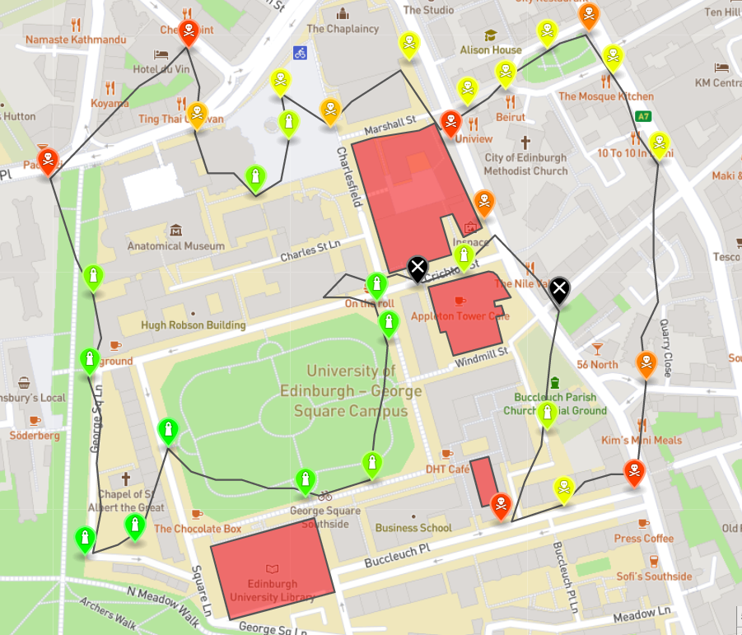

**4. References**

①Course INFR08026, Introduction to Algorithms and Data Structures, Coursework problem sheet 3, March 2020

②Introduction to A*. (n.d.). Retrieved December 03, 2020, from http://theory.stanford.edu/~amitp/GameProgramming/AStarComparison.html